**Sample Email for Multinational Copyright License Holders**

The following is provided to assist you in introducing the Multinational Copyright License and RightFind® Advisor to employees. You can use this text in an email message, posting on your company intranet, or in your company newsletter.

**Subject: Compliant collaboration using published content is easier than ever with our new Multinational Copyright License**

The Multinational Copyright License enables [company name] employees to reuse and collaborate using content from millions of publications from thousands of copyright holders from around the world.

Did you know that permission is needed from the copyright holder to reuse externally sourced print and digital content?

That is why we’re excited to introduce the Multinational Copyright License from Copyright Clearance Center, a single source, global licensing solution that complements our existing publisher agreements and subscriptions to enable you to efficiently collaborate using published content and simplify copyright compliance with easy rights lookup.

How can the Multinational Copyright License can help you?

Print and digital content can come from many sources and understanding when additional rights are required to reuse that content can be time-consuming and complicated. The Multinational Copyright License delivers millions of rights, removes the guesswork, and makes it easy for you to:

* Email a PDF of a journal article to a colleague in conjunction with a collaborative project you are working on together
* Host a competitive intelligence collaboration site for project teams that includes news articles, published literature, press releases, market reports, and other content related to direct competitors
* Embed a PDF of a recent article about the company into an internal company newsletter or post it to the company’s intranet site for employee awareness
* Use portions of a work in an internal presentation at a company meeting or in an employee education program
* Store a copy of an electronic article on the company intranet for use by a project team
* Store the full text of an article to substantiate claims made in promotional materials in the same system that was used to develop, manage, and approve the content
* Annotate and store copies of scientific articles related to known adverse events of a company product in an internal database which is used by a small team in connection with the company’s regulatory compliance obligations
* Annotate and submit supporting articles to a government agency as required as part of a regulatory or patent filing

*How can you check what’s covered with the Multinational Copyright License?*

The Multinational Copyright License comes with **RightFind® Advisor**, a quick, reliable way to verify rights included in the license. [Click here](https://rightfind.copyright.com/rs-ui-web/welcome) to log in or visit our intranet to access RightFind Advisor and then enter the Publication Title or Standard Number (ISBN/ISSN) in the search box.

License coverage, shown in the screenshot below, is listed under “*How can I use this copyright content?*”

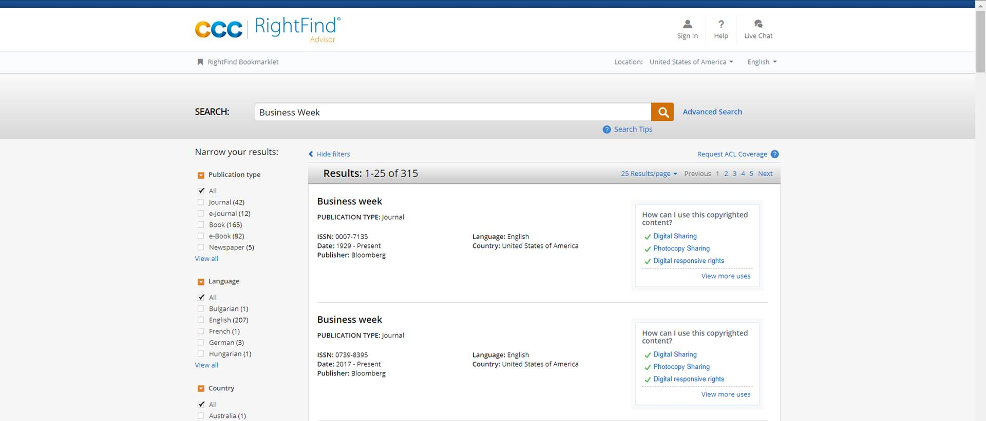

For more information about our Multinational Copyright License, please contact [company contact] at [email or extension].